

**Solution:-**

Created a reference named **‘a’** and referred the file named Employee_Details.txt.



Loaded the file that is referred by **‘a’** using dump command.



Please find the output of **“dump a”** below.

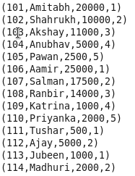

Here the file referred by ‘a’ is ordered in such a way that **“ratings are ordered in descending and If ratings are equal for some tuples, then for those tuples, order id in ascending order.”** In this way, we can get the employees with highest rating and **if ratings are equal, we can get the employees names coming first with the help of id.** The ordered file is referred by **op** variable.

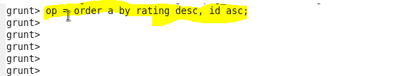

We have **loaded the file that is referred by op.**

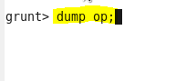

Please find the output of **dump op** below.

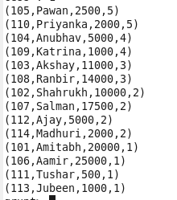

Using **Limit** command, we can **filter the first 5 tuples of ordered file** and is referred by **‘b’.**

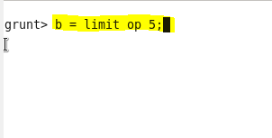

We have **loaded the file that is referred by b** using dump command**.**

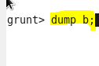

Please find the output of **dump op** below.

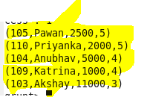

Now in the output, **we need only the employee id’s and names of the file referred by op.**

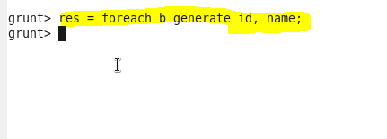

We have **loaded the file that is referred by res** using dump command**.**



So, you can find the required result below.

